
WEEK 2
Allergen Chart Primary School Spring/Summer 2024
Recipe Description  Contains X May Contain O | 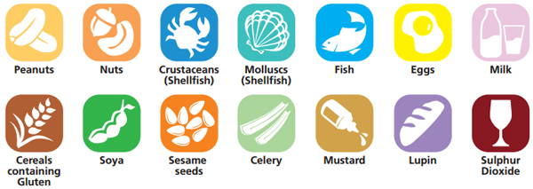
MONDAY
Vegetable Pasta Bolognaise |  |  |  |  |  |  |  | X
Margherita Pizza |  | O |  |  |  |  | X | X | X
Potato Wedges
Iced Sponge |  | X |  |  |  |  |  | X
TUESDAY
Breaded Chicken Steak |  |  |  |  |  |  |  | X
Southern Style Quorn |  | X |  |  |  |  | X | X
Diced Potatoes
Ice Cream Sundae |  |  |  |  |  |  | X
WEDNESDAY
Roast Pork
Roast Quorn |  |  |  |  |  |  |  | X
Roast Potatoes
Jelly & Ice Cream |  |  |  |  |  |  | X
THURSDAY
Sweet & Sour Chicken |  |  |  |  |  |  |  |  |  |  | X
Rice
Vegetable Chow Mein |  | X |  |  |  |  |  | X | X |  |  |  |  | X
Shortbread Biscuit |  |  |  |  |  |  |  | X
FRIDAY
Fish Fingers |  |  |  |  |  | X |  | X
Vegetable Spring Roll |  |  |  |  |  |  |  | X | X | X
Chips
Lemon Drizzle Cake |  | X |  |  |  |  |  | X

The chart should be marked to signify where allergens are present; a blank square signifies that none of the above allergens are contained in the recipe.

